**Data Communication and Computer Network**

**Assignment – 1**

**Applications of Satellite Communication**

**Introduction - satellites**

A satellite is a man-made article that is placed purposefully into the orbit of any natural satellite. Satellites are utilized for numerous reasons for example weather conditions determining, computerized transmission, logical innovative work and scientific research, and so on. When we talk about this in the context of our subject i.e. communication, we define satellite as a specific remote transmitter/receiver sent off by a rocket and put in orbit around the earth. A satellite can be normal, similar to the moon, or artificial/man-made. So, we can say that a satellite is an object that moves in a curved way all over a planet providing various communication and other facilities.

Below is the image of how an artificial satellite looks like and the image is referred from [*https://www.techgeek360.com/artificial-satellites-working/*](https://www.techgeek360.com/artificial-satellites-working/):

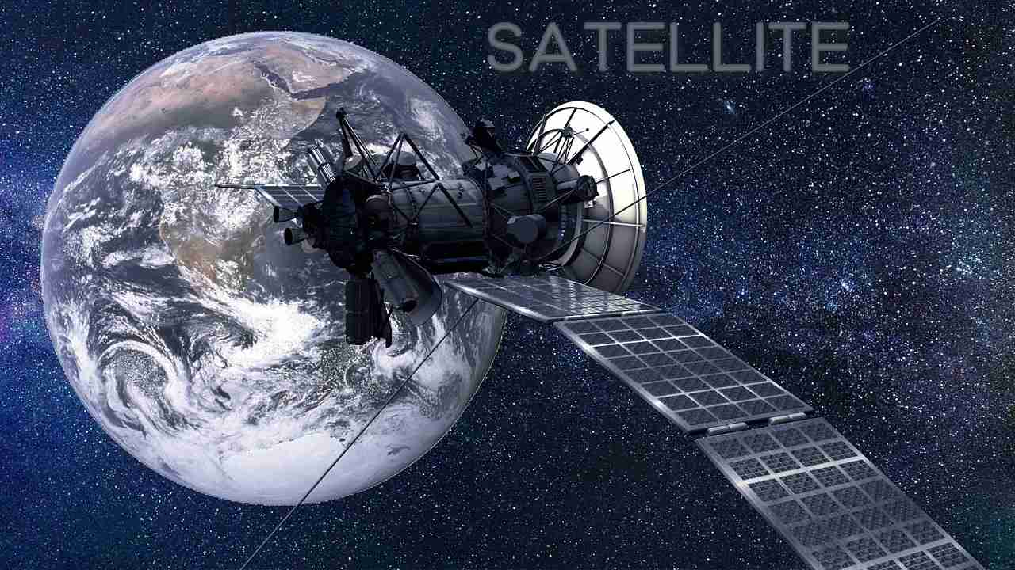 Figure - 1

**Introduction – satellite communication**

There have been numerous satellites launches and each of them serves a purpose ranging from communication satellites to military satellites and various applications. Now moving to Satellite communication, it refers to the framework or setting where we transport information from one place to another using the satellite that is orbiting around the Earth.

Let’s take a simple example to understand this better. You are sitting at your home and watching IPL on your Television. How is this possible, ever wondered? Well, Satellite Communication has made this possible. You are sitting at one nook of Earth and you can use satellite communication to call, text, or even exchange information to a person or group of persons at another cranny of Earth. This is all possible due to Satellite Communication.

Below is the image of various domains where satellite communication happens and the image is referred from [*https://www.gl.com/telecom-test-solutions/testing-satellite-communications.html*](https://www.gl.com/telecom-test-solutions/testing-satellite-communications.html):

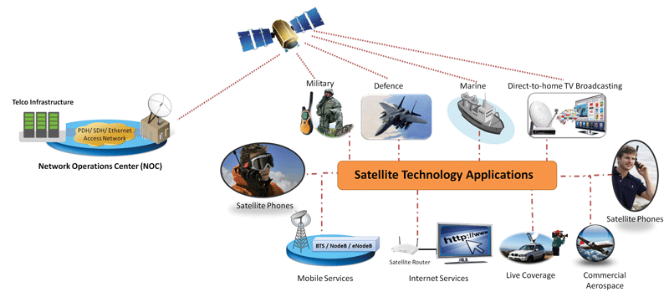Figure -2

Now, Let’s look at what a communication satellite is. It is a man-made satellite that serves the purpose of transmitting signals through a transponder as it creates a channel or link between the transmitter and the receiver situated at extremely distinct places. Television, radio, internet, Telephone, and even military applications all work due to satellite communications. One might wonder for so many purposes is one satellite enough and efficient. Well to answer this, let me state the fact that there are more than 2000 artificial satellites in space right now.

**How does Satellite Communication work?**

The communication satellites help us to transmit signals like radio, web information, and TV from one part of the planet then onto the next. It includes three phases that can assist with the working. These phases are:

1. Uplink

2. Transponders

3. Downlink

We will talk about these phases with the help of an example of television signals. In the principal stage, the signal from the television broadcast on the earth's opposite side is first radiated up to the satellite from the ground station. This process is referred to as uplink.

The subsequent stage comprises of transponders like radio receivers, amplifiers, and transmitters. We utilize these transponders to boost the incoming signal and for changes in their frequency. This aids in the outgoing signals not being changed. The transponders fluctuate contingent upon the incoming signal sources.

At last, the third stage includes a downlink in which it sends the information to the other end of the recipient on the earth. It is basic to comprehend that generally there is one uplink and various downlinks.

Below is the image of How Satellite Communication work and this image is referred from [*https://www.electronicslovers.com/2018/02/basic-concepts-of-satellite-communication-for-beginners.html*](https://www.electronicslovers.com/2018/02/basic-concepts-of-satellite-communication-for-beginners.html):

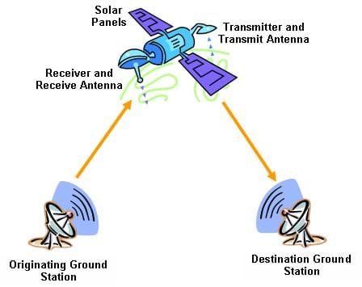 Figure – 3

**Applications of Satellite Communication**

1. Satellites for Navigation:

Despite the fact that it was just utilized for military purposes before all else, the GPS (Global Positioning System) is these days notable and accessible for everybody. All our route frameworks, Google maps, and so on take into consideration exact localization around the world, and for certain extra features, the accuracy is in the scope of certain meters. Practically all aircraft and ships depend on GPS as an expansion to conventional navigation frameworks. Numerous vehicles and trucks accompany introduced GPS receivers. This framework is likewise utilized for fleet management of trucks or for vehicle identification in the event of a robbery.

Below is the image for Satellites for navigation and is referred from [*https://asianlite.com/2014/top-news/india-moves-towards-own-navigation-satellite-system/*](https://asianlite.com/2014/top-news/india-moves-towards-own-navigation-satellite-system/):

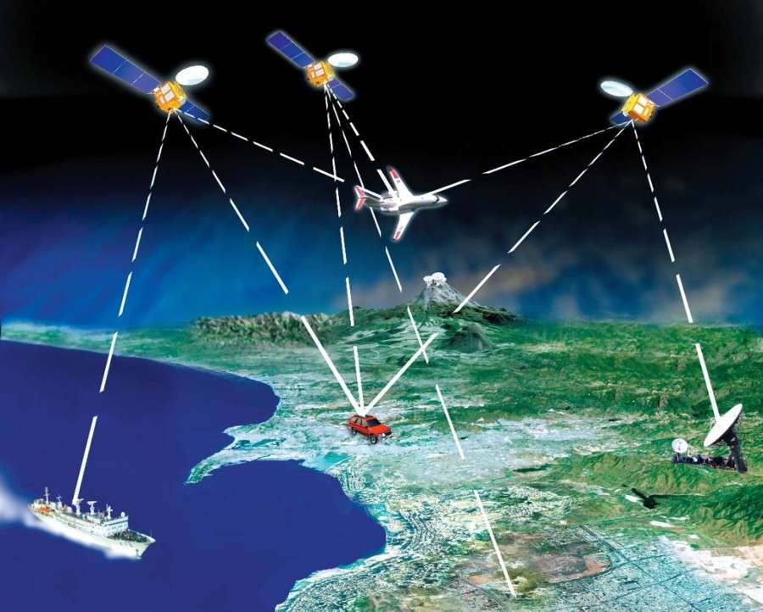 Figure - 4

2. Worldwide Mobile Communication:

The most recent trends of satellites uphold worldwide mobile data communication. Because of the great inactivity, geostationary satellites are not great for this undertaking; accordingly, satellites utilizing lower orbits are required. The essential purpose behind satellites for mobile communication isn't to replace the current mobile phone networks but is to expand the area of coverage of mobile networks. Cellular frameworks, for example, AMPS and GSM, and their replacement don't cover all places of a country.

Below is the image for Worldwide mobile Communication and is referred from [*https://telecomglobal.wordpress.com/2013/07/02/gsm-global-system-for-mobile-communication/*](https://telecomglobal.wordpress.com/2013/07/02/gsm-global-system-for-mobile-communication/):

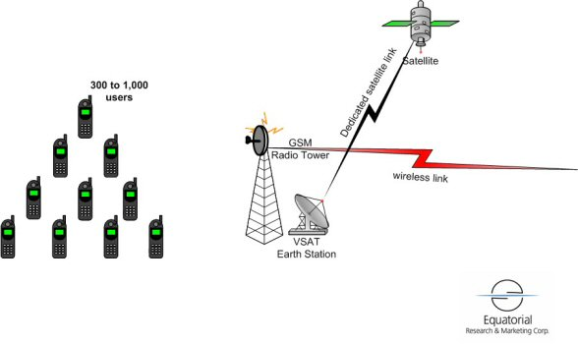Figure - 5

3. Radio and TV broadcast satellites

Many TV and radio projects are accessible by means of satellites. This innovation involves links in many spots, as it is less expensive to introduce and, generally speaking, no additional charges must be paid for this assistance. The present satellite dishes have measurements of 30-40 cm in central Europe, and the diameters across northern nations are somewhat bigger.

Below is the image for Radio and Tv broadcast satellites and is referred from [*https://electronics.howstuffworks.com/satellite-tv2.htm*](https://electronics.howstuffworks.com/satellite-tv2.htm):

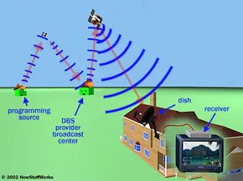 Figure - 6

4. Weather conditions forecasting

Without the assistance of satellites, we can't foresee climate. Satellites have the greatest commitment to making expectations about weather conditions changes by concentrating on the few worldwide situations. A few satellites convey photos of the earth utilizing infrared or noticeable light. Weather conditions estimating is done through fitting extraordinary instruments and strong cameras in the satellites which screen different environmental factors, for example, air pressure, air temperature, humidity, and so on. The satellites made for weather conditions determining are called weather satellites.

Below is the image for Weather conditions forecasting and is referred from [*https://www.ecmwf.int/en/research/data-assimilation/observations*](https://www.ecmwf.int/en/research/data-assimilation/observations) :

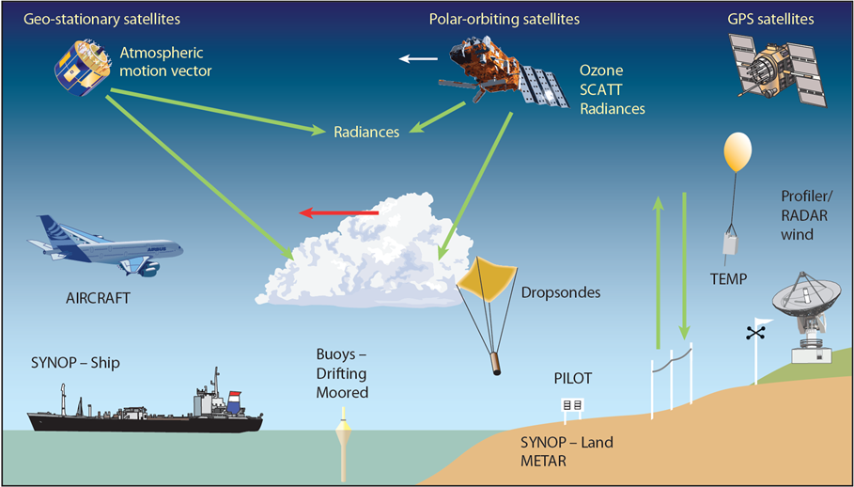Figure - 7

5. Military satellites

Probably the most established/oldest utilization of satellites was their utilization for doing surveillance. A large portion of the communication links is managed through satellites since they are a lot more secure from assault by enemies.

Below is the image for Military Satellites and is referred from [*https://en.wikipedia.org/wiki/Military_satellite*](https://en.wikipedia.org/wiki/Military_satellite) :

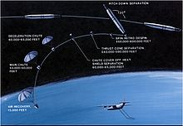 Figure - 8